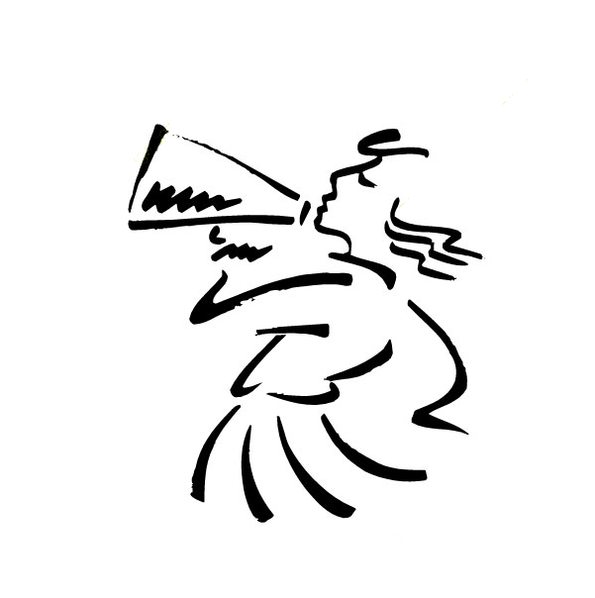
Scott Community High School
Cheer Constitution

The purpose of SCHS cheerleading is to promote and uphold school spirit, to develop good sportsmanship among the students, to support athletic programs, and to promote SCHS in a positive manner to our community and to the communities of our opponents.

Take your spot and use it well
Teach our crowd to cheer and yell!
Be more than a team
A family united
To show this town we are strong
Never back down
For the fans, alumni, and students
Be Proud!
You are a Scott City Cheerleader – Yell Leader now!
- Rachel Anliker, SCHS Alum

Duties of the Squad:
- Promote and uphold school spirit.
- Serve as a leader of the student body.
- Be loyal to your school and team regardless of the outcome of the game.
- Set an example of good behavior and sportsmanship at all times, whether in uniform or not.
- Promote friendship with each other and with the schools with whom we compete, perform, and go to camp.
- Be active in and promote community service.

To Letter in Cheer:
- Cheer at 100% of varsity events as assigned by the coach and/or principal unless excused by the coach and/or principal.
- Follow all rules and regulations that any SCHS athlete must follow, including training rules and KSHSAA rules.

** Any member who has been disciplined for bullying, harassment, intimidation, tobacco use, use of alcohol, other forms of inappropriate conduct, or more than one unexcused absence (practice, activity, or game) will NOT letter and could be dismissed from the squad.

Requirements to be a Member:
- Membership is open to 8th grade – 11th grade during the spring in which tryouts are held.
- Cheer season is split into a fall season (football) and a winter season (basketball and wrestling).
- All members are expected to participate in both the fall and winter season (a member may participate in another sport concurrently, and will split practice time between the two sports so as to assist in your success in both sports).
- Members are expected to attend summer weights and conditioning in preparation for the season to come. It is also highly encouraged that the student take weights or aerobics during the fall semester.
- There will be practice in June to prepare us for cheer camp and again in August before school starts to begin preparation for the coming season.
- Members must have a physical examination on file in the office.
- Members MUST be physically able to participate in all areas of cheerleading (cheers, jumps, stunting, dancing, etc.).
- Members must maintain eligibility as set up by KSHSAA and the USD 466 Board of education.

Tryouts:
- The squad will be selected in the spring for the following year.
- Tryouts will be held and they will be closed to spectators.
- All candidates must attend the pre-tryout training sessions.
- All candidates must return a signed parental permission form, grades signed by the counselor or principal, and teacher evaluations before the date stated on the tryout form.
- Each candidate will be scored on a mandatory chant, cheer, dance, and jump
- Judges will be selected to come and score the tryouts. These judges will be from a high school or college that is not associated with SCHS in order to have a fair and unbiased selection.
- Teacher evaluations, grades, and attendance records will all be part of the tryout as well. The judges’ scores will be half of the tryout with the evaluations and grades making up the other half.

Financial Responsibilities:
- Uniforms are required for participation on the squad. They are to be kept in good condition and clean at all times. Any repairs or alterations are the responsibility of the individual. If there are problems with the uniform not due to regular wear and tear, individuals must contact the coach to see if there is any recourse with the supplier.
- Camp attendance is mandatory in order to participate on the Cheer Squad. Camp fees are the responsibility of the cheer squad member.
- Deposits made for cheer clothes, shows, and/or camps are no-refundable.
- Additional expenses such as hair ties, camp clothes, and team arm-ups are the responsibility of the squad member.
- Fundraising opportunities are available. However, it is the individual’s responsibility to pay all expenses.
- All cheer expenses must be paid on the state due dates. If the commitments are not taken care of, the member will sit out until tall expenses are paid.
- If a member of the squad chooses to quit or is dismissed, they are still responsible for these fees. Grades and transcripts will be held until they are paid.

Communication:
- Members will be given a schedule at the beginning of each cheer season for practices, games, and uniforms. It will also be posted on MyBigCampus.com.
- If a member is to be absent or tardy to practice or a game, the coach must be notified in advance.
- When at all possible, the squad will be notified at least 24 hours in advance of any practice, special event, or changes in the schedule.

Transportation:
- Members will ride in school transportation both to and from the athletic events, unless a member has their parent’s written permission to ride home with them. Specific forms are available at the SCHS office or on MyBigCampus.com.
- On an overnight stay, squad members will stay with the squad.
- At the discretion of the SCHS Athletic Director or Principal, a squad member may be able to ride to the game with their parent.
- Squad members are never permitted to drive to the game independently or with friends or non-guardian adults.
- Unless transportation allows, only 16 members will travel to away games. Members will be chosen based on seniority.
- Only four cheerleaders will go to state wrestling. Those with the most seniority will have priority, followed by the squad members that attended the most tournaments throughout the season.

Attendance in Cheerleading:
Members make and are expected to honor their commitment to be in attendance to support their school and their squad members. For this reason, members should be aware what they are committing to when they try out for cheer. Possible personal conflicts can be worked out in advance as allows by the rules set out in this constitution. Also, any member that quits during the cheer season will not be allowed back on the squad and will not be invited to try out again during high school.
- Cheer is a school-sponsored activity and has priority over non-SCHS activities.
- All state and sub-state games MUST be attended by the entire squad.
- Members must be in attendance in school on game days or they will not be allowed to cheer that night. You must be in school all day to participate that night.
** Doctor and other medical appointments are exceptions but you must notify the coach and bring a doctor’s note to the office
- If a member comes to school and is or becomes too ill to attend or cheer at the game, the parent or student must notify the coach as soon as possible.
- If a member has to miss practice because of a doctor’s appointment, he or she must turn in a note from the doctor’s office to Coach Neri. If the appointment concludes before the end of practice, the member come to what remains of practice.
Excused Absences include:
- Illness
- Death in the family
- Serious illness in the family
- Injury (sprained ankle, pulled muscle, broken bones, concussions, etc)
- Family emergency
** Other extenuating circumstances must be discussed with the coach in as much advance as can be foreseen.
Unexcused Absences include:
- Work
- Babysitting
- Dates
- Forgetting
- Birthday parties
- Plans with friends
- Hair appointments
- Non-SCHS sponsored activities
Failure to follow the above guidelines can result in a member being suspended, benched, or dropped from the squad. You will receive a practice and game schedule well in advance so you can plan accordingly around the schedule.

Conduct and Responsibility:
- Cooperate with captains, co-captains, advisor, coaches, AD, principal, and game officials.
- During a game, members should be peppy, well-groomed, and in command of the situation at all times. Leave any problems and attitudes at the door.
- Members will not sit in the stands or leave the squad until the game ends and dismissed by the coach. Restroom breaks can be taken before/between the game(s) and during half-time.
- Members are responsible for helping to influence and control the attitudes of the crowd as much as possible.
- Members shall be on time for all practices, games, and events and dressed and ready to go in the correct uniform.
- Members shall attend all designated events unless excused by the coach.
- Members must make an attempt to understand the sport at which they cheer so as to be prepared to give appropriate cheers.

Uniforms and Appearance:
- Uniforms or team-designated outfits must be clean/stain free if they are to be work to school, activities, or games. Please follow the appropriate uniform care.
- When traveling to events, all squad members should be dressed alike – typically in your warm ups.
- Hair will be pulled back and off the shoulders at all times. Bangs must not cover the eyes. This a safety procedure when it comes to safe stunting.
- NO GLITTER on face, clothes, or hair.
- NO JEWELRY or pins. This is a safety procedure.
- Skirt length shall be worn as specified by the coach. You may not cut off any skirt length.
- Members must wear the designated uniform when called for.

Other regulations and standards:
- Visiting teachers and making up missing work must be done before school. Please plan accordingly.
- If you are required to attend ASP you must do so before school whenever possible so as not to adversely affect the rest of the squad at practice. If you have more ASP then just going before school allows and must go after school, you must come to practice directly after ASP.
- Any practice held on school property must have a coach present.
- There will be NO stunting unless a coach is present to supervise.
- Members may not cheer at games until they have sufficient knowledge of the chants, cheers, stunting, and band songs to perform them creditably.
- Yell for your team, not against the other team.
- Never lose your cool at games or events.
- Never yell swear/suggestive words or use inappropriate hand gestures. This will result in disciplinary action.
- No talking/yelling during foul shots, or clapping when the opponent misses.
- Members must be on the field/court at least 2 minutes prior to the start of the game/half.
- Members must participate in all fund and spirit raising events.
- Members are expected to follow the rules set by the coaches or bus driver on any bus to an event.
- If injured, members are still expected to be a part of the squad and attend practices and games, as well as dressed as part of the squad.

Bullying, Harassment, and Intimidation
- Bullying, harassment, and intimidation are unacceptable behaviors for members of the cheer squad and will not be tolerated.
- The cheer squad will follow USD 466 policy with regards to these behaviors.
- If a member feels they are being targeted in any way, they are to report the behavior to the coaching staff as soon as possible. If you are uncomfortable speaking to us, you may use email to make contact.
- Any member who has been a witness to a student or squad member being bullied must also report the incident. Failure to do so is also subject to disciplinary action.
- Once the coach staff receives the complaint or email they will discuss the issue with the target as well as report the incident to administration.
- Following that discussion, the coaching staff will meet with individuals who are exhibiting the bullying or intimidating behavior to allow that person to understand how their behavior has been perceived and that the behavior must stop. The parents of all students involved will be contacted by the coaching staff or the administration.
- If the behavior continues, the target must inform the coaching staff.
- At this point, the administration will be notified and the individual who has been exhibiting the bullying behavior will be removed from the squad.

Consequences:
The coach shall have the power to suspend, bench, or drop any squad member for the following:
- Undesirable behavior
- Sloppy appearance or habits
- Undesirable language or gestures
- Failure to perform duties as outlined in the constitution
- Violation of the rules and regulations
- Any act that harms the reputation of the school
- Failure to learn cheers or work for the squad
Unexcused tardy/absence to practice, unexcused tardy to games, early departure from game, wrong/incomplete uniform, forgetting poms, cell phone use at practice or games, jewelry at practice/game:
- First Violation: sit out for a quarter or part of the game (coach’s discretion)
- Second Violation: Benched for a game
- Third Violation: Suspension or Dismissal from Squad (coach’s discretion)
Unexcused absence from game:
- First Violation: Benched for a game
- Second Violation: Dismissal from squad
Drinking, tobacco use, discredit to the team, arrest:
- Consequences as per SCHS guidelines
- First Violation: Benched for 2 games, pending dismissal from squad
** Other issues may arise during the course of the cheer seasons. These instances will be handled by the coaches using their discretion. If the coach must speak to a member to about a particular behavior, this is considered a warning and should be corrected. If the request from the coach is not followed, the squad member will be benched from a game for not following a direct request from the coach.

